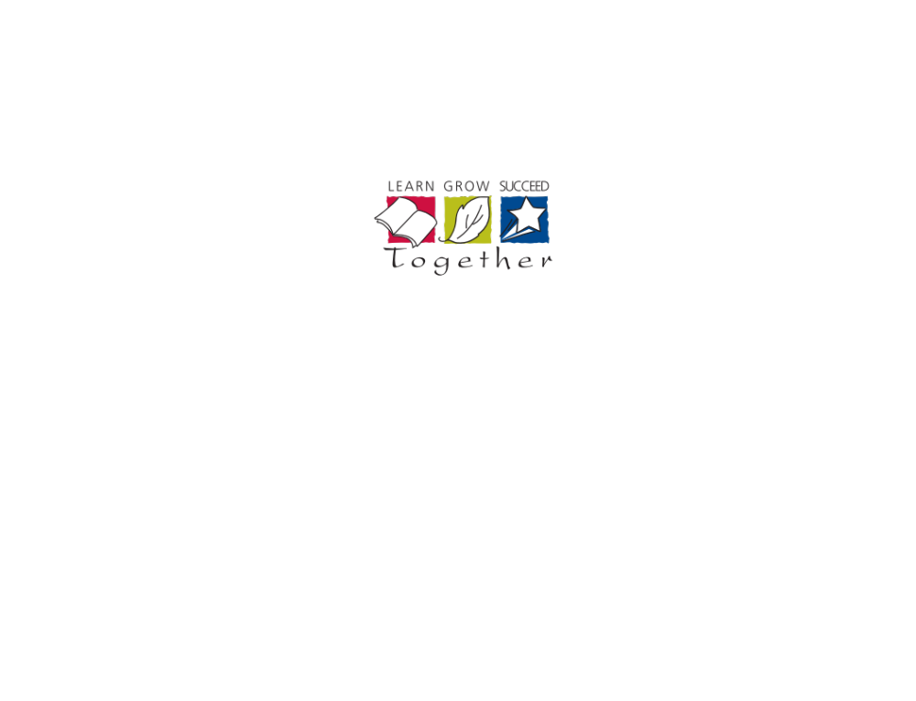 | PAF4O – Personal Activities and Fitness- Course Outline
Ms. L. Zazzara | CHATT Email: zazzaral@hdsb.ca | Website: zazzaral.weebly.com
Ms. L. Zazzara | Office Hours: Periods 3 and 5 | Room: Girls PE Office

This course focuses on the development of a personalized approach to healthy active living through participation in through participation in a variety of physical activities that have the potential to engage students' interest throughout their lives. Students apply movement principles and guidelines and strategies to refine skills and to actively participate in personal and fitness activities (e.g. Tae-Bo, cycling, in-line skating, strength training) to enhance their personal competence and personal fitness. Students will develop and implement personal physical fitness plans. In addition they will be given opportunities to refine decision-making, conflict resolution, and interpersonal skills with a view to enhancing their mental health and their relationship with others.

Curriculum
Students final report card grade will be based on the evidence provided of these overall curriculum expectations:
• demonstrate personal movement competence (skills and principles)
• demonstrate knowledge of guidelines and strategies to enhance participation in personal and
fitness activities
• demonstrate regular participation
• demonstrate improved personal physical fitness
• demonstrate safe practices
• use decision making skills and goal-setting skills to promote healthy active living
• use stress management techniques
• demonstrated appropriate social skills and transfer to lifelong practices
• demonstrate an understanding of health concepts

Term work:  70% of your grade will be based on all of the evidence you have provided. It will reflect your most consistent level of achievement with special consideration given to more recent evidence. | 7 % Knowledge and Understanding: Emphasizes the ability to recall factual information, recognize fundamental concepts and the foundational skills of the subject/discipline.  15 % Thinking: Emphasizes the thinking skills used in thinking processes to demonstrate the students’ understanding of information they have processed.  10 % Communication: Emphasizes the clear, precise and effective use of oral, written and visual language to communicate the student’s understanding of information and ideas  38 % Application: Emphasizes the application and integration of skills, processes and techniques to produce evidence of the student’s understanding.
Final Evaluation:  30% of your grade will be determined at the end of the course. | 10 % Performance Task  Students will demonstrate personal movement competence in applying complex movement skills (e.g. combination of locomotion, stability and manipulation skills) through fitness activities (e.g. cycling, in-line skating, Tae-bo, strength training, yoga, fitness circuits).
10 % Performance Task
Students will demonstrate a refinement of guidelines and strategies that enhance participation in personal and fitness activities (e.g., correct breathing and training techniques, safe practices, fundamentals of circuit training, road and trail etiquette etc.).
10% Written Analysis
Students will complete a lifestyle analysis and set goals for improving areas related to their social, emotional, and physical well-being. Students will use the information to design a wellness plan to enhance their well-being and promote lifelong healthy active living. Information that should be included in the plan is: strategies for lifelong participation, a variety of fitness equipment, programs and approaches, evaluation of community fitness programs, or approaches and strategies which promote mental health.
Your final grade will be calculated by combining your Term (70%) grade and your Exam and Performance Task Evaluations (30%).

Your Report Card Grade will be determined as follows:

Academic Standards
It is your responsibility to provide evidence of your learning within established timelines. Due dates for assignments and the scheduling of tests will be communicated well in advance to allow you to schedule your time. If you aren’t going to be able to follow an agreed upon timeline you should demonstrate your responsibility and organizational skills by discussing with your teacher the challenges you’re facing as far in advance of the deadline as possible.
It is your responsibility to be academically honest in all aspects of your schoolwork so that the marks you receive are a true reflection of your achievement.
Plagiarism is using the words, ideas or work of someone else without giving appropriate credit to the original creator. This is a form of cheating.

Consequences for not meeting these academic standards may include:
- Reporting the issue to your parents;
- Requiring you to complete the original or alternative work after school or during your lunch hour;
- Requiring you to complete an alternative assignment;
- Suspension;
- Assigning a “zero” for an assignment not completed prior to an agreed upon closure date;
- Mark deduction of 5% / day.

NOTE: the complete HDSB policies and administrative procedures for “Lates and Missed Assignments” and “Cheating and Plagiarism” policies may be found at www.hdsb.ca

Learning Skills and Work Habits
The development of learning skills and work habits are an important step toward preparation for post-secondary education and the world of work. Students will develop these skills through their classroom experience and with feedback from their teacher.


